VAST spatial delta-GLMM Evaluation

# Knot Number Sensitivity and Comparison with Design-based Estimates

The knot number in a VAST spatial delta-GLMM model specifies the level of spatial complexity (Fig. 1). For a given number of knots specified by the user, the k-means algorithm is used to identify the optimal location of these knots to minimize the total distance between available data and the location of the nearest knot. To evaluate the sensitivity of model-based survey index and variance estimates to the number of knots specified, separate VAST models were run for a range of species of interest in the Gulf of Alaska and Aleutian Island surveys. Annual values and uncertainty (CV) estimates for the VAST model-based and traditional design-based indices are compared below.



Figure 1 Example from of how the knot number specification influences the level of spatial complexity within a VAST model, from GOA Northern Rockfish.

## Gulf of Alaska Bottom Trawl Survey

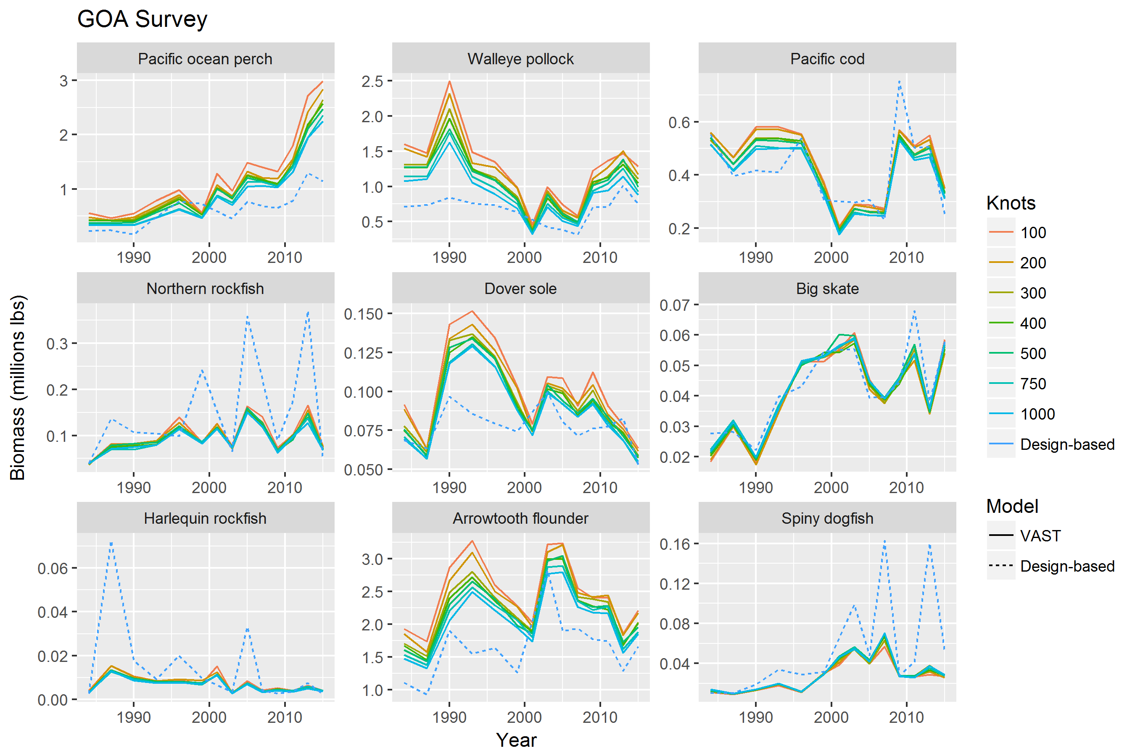

Figure 2 Comparison of annual survey index estimates across species, models, and VAST knot number specifications, for the Gulf of Alaska bottom trawl survey. Each boxplot describes the distribution of estimated CV’s across survey years.

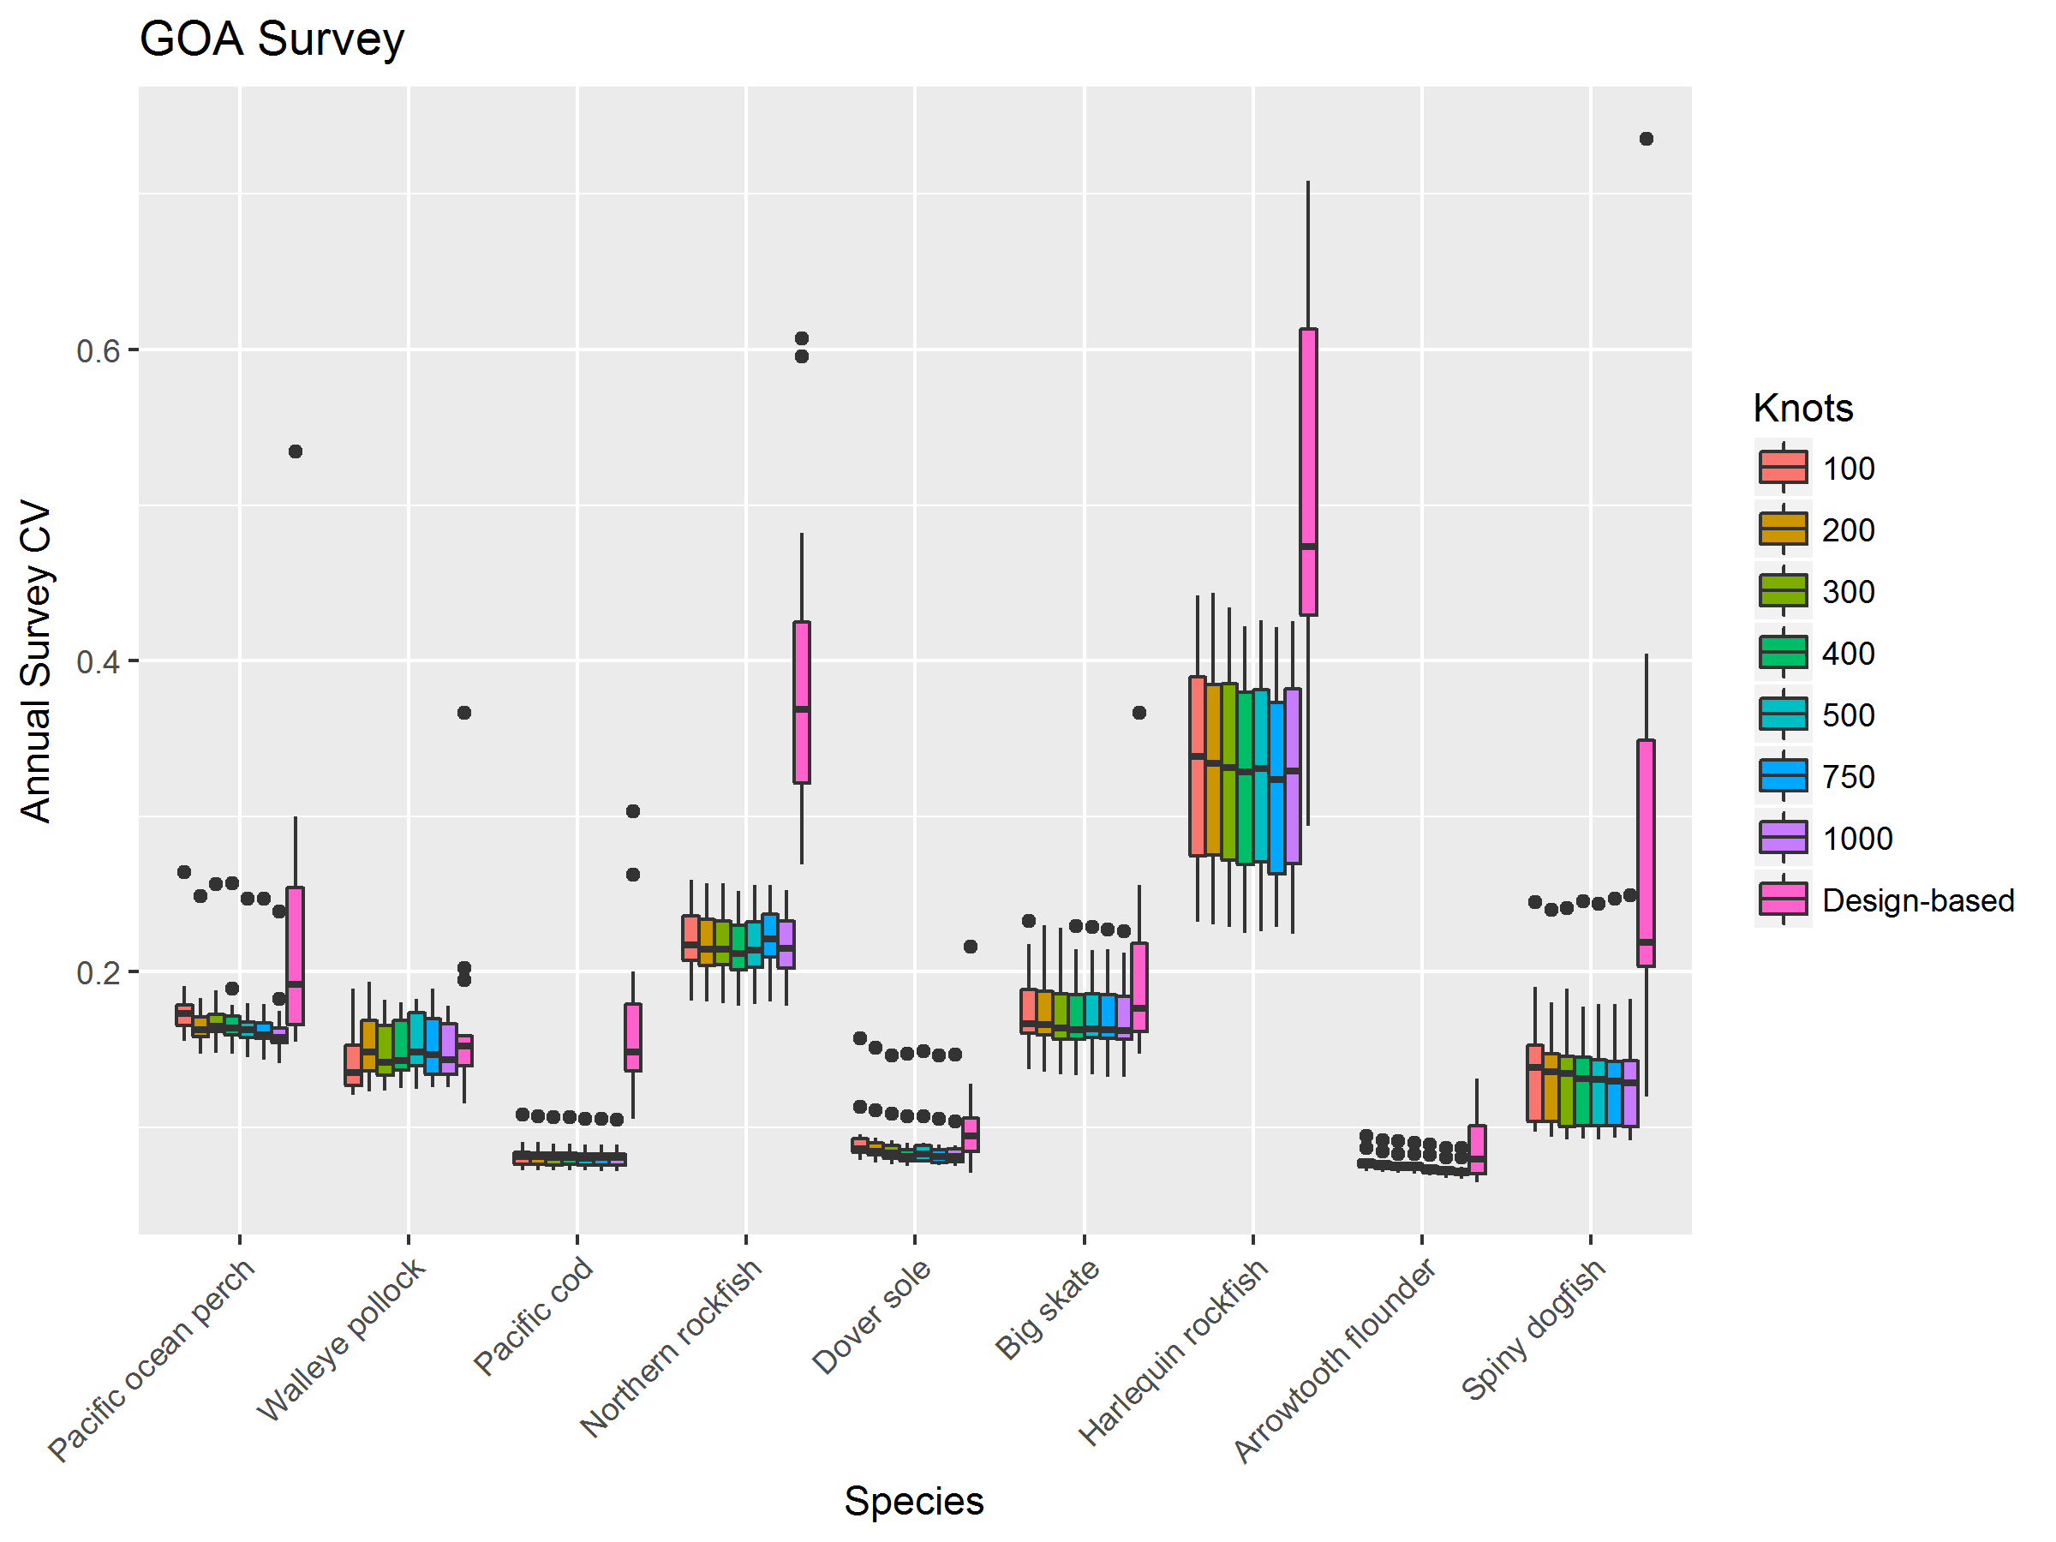

Figure 3 Comparison of annual survey uncertainty (CV) across species, model types, and VAST knot number specifications, for the Gulf of Alaska bottom trawl survey. Each boxplot describes the distribution of estimated CV’s across survey years.

## Aleutian Islands Bottom Trawl Survey

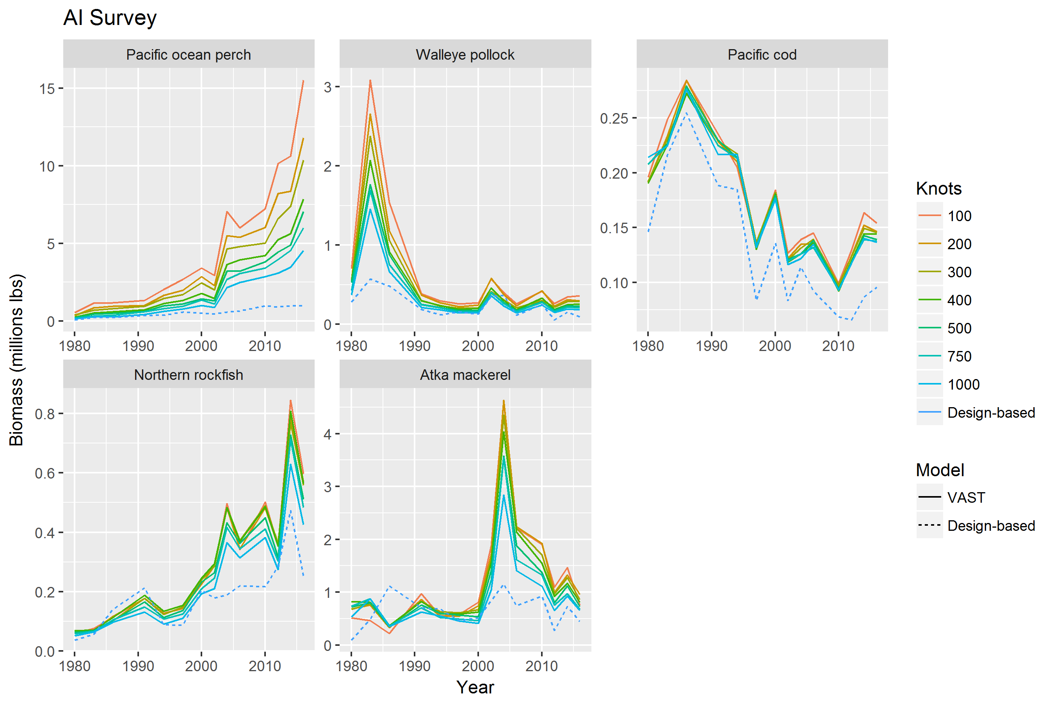

Figure 4 Comparison of annual survey index estimates across species, models, and VAST knot number specifications, for the Aleutian Islands bottom trawl survey. Each boxplot describes the distribution of estimated CV’s across survey years.

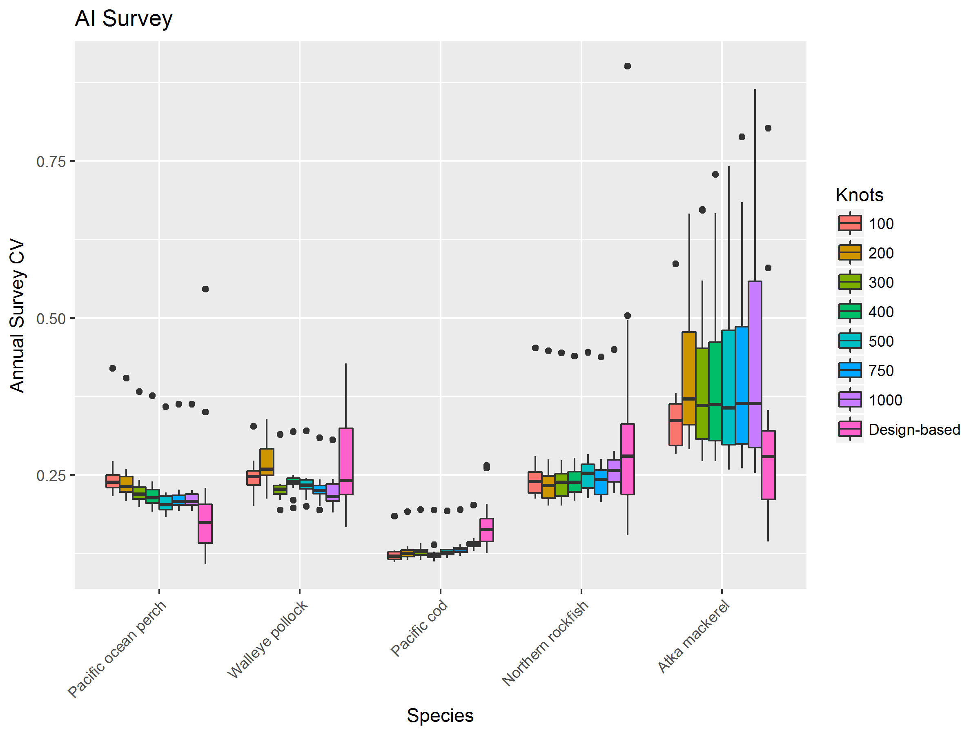

Figure 5 Comparison of annual survey uncertainty (CV) across species, model types, and VAST knot number specifications, for the Aleutian Islands bottom trawl survey. Each boxplot describes the distribution of estimated CV’s across survey years.

# Gulf of Alaska Apportionment Comparison

One areas of interest outlined in previous discussions was the use of area-stratified VAST models for apportionment calculations. Within the Gulf of Alaska, apportionment estimates were compared between the stratified VAST model and the ADMB-RE model. Inputs for the ADMB-RE model were separate design-based indices generated for the Western, Central, and Eastern GOA, and the ADMB-RE model assumed separate process errors for each index. Results were rather insensitive to a range of knot numbers, (knots=500 shown below), and whether the intercepts for both encounter probability and positive catch rate components of the spatial delta-GLMM were specified as random-walk or lag-1 auto correlated processes over time.

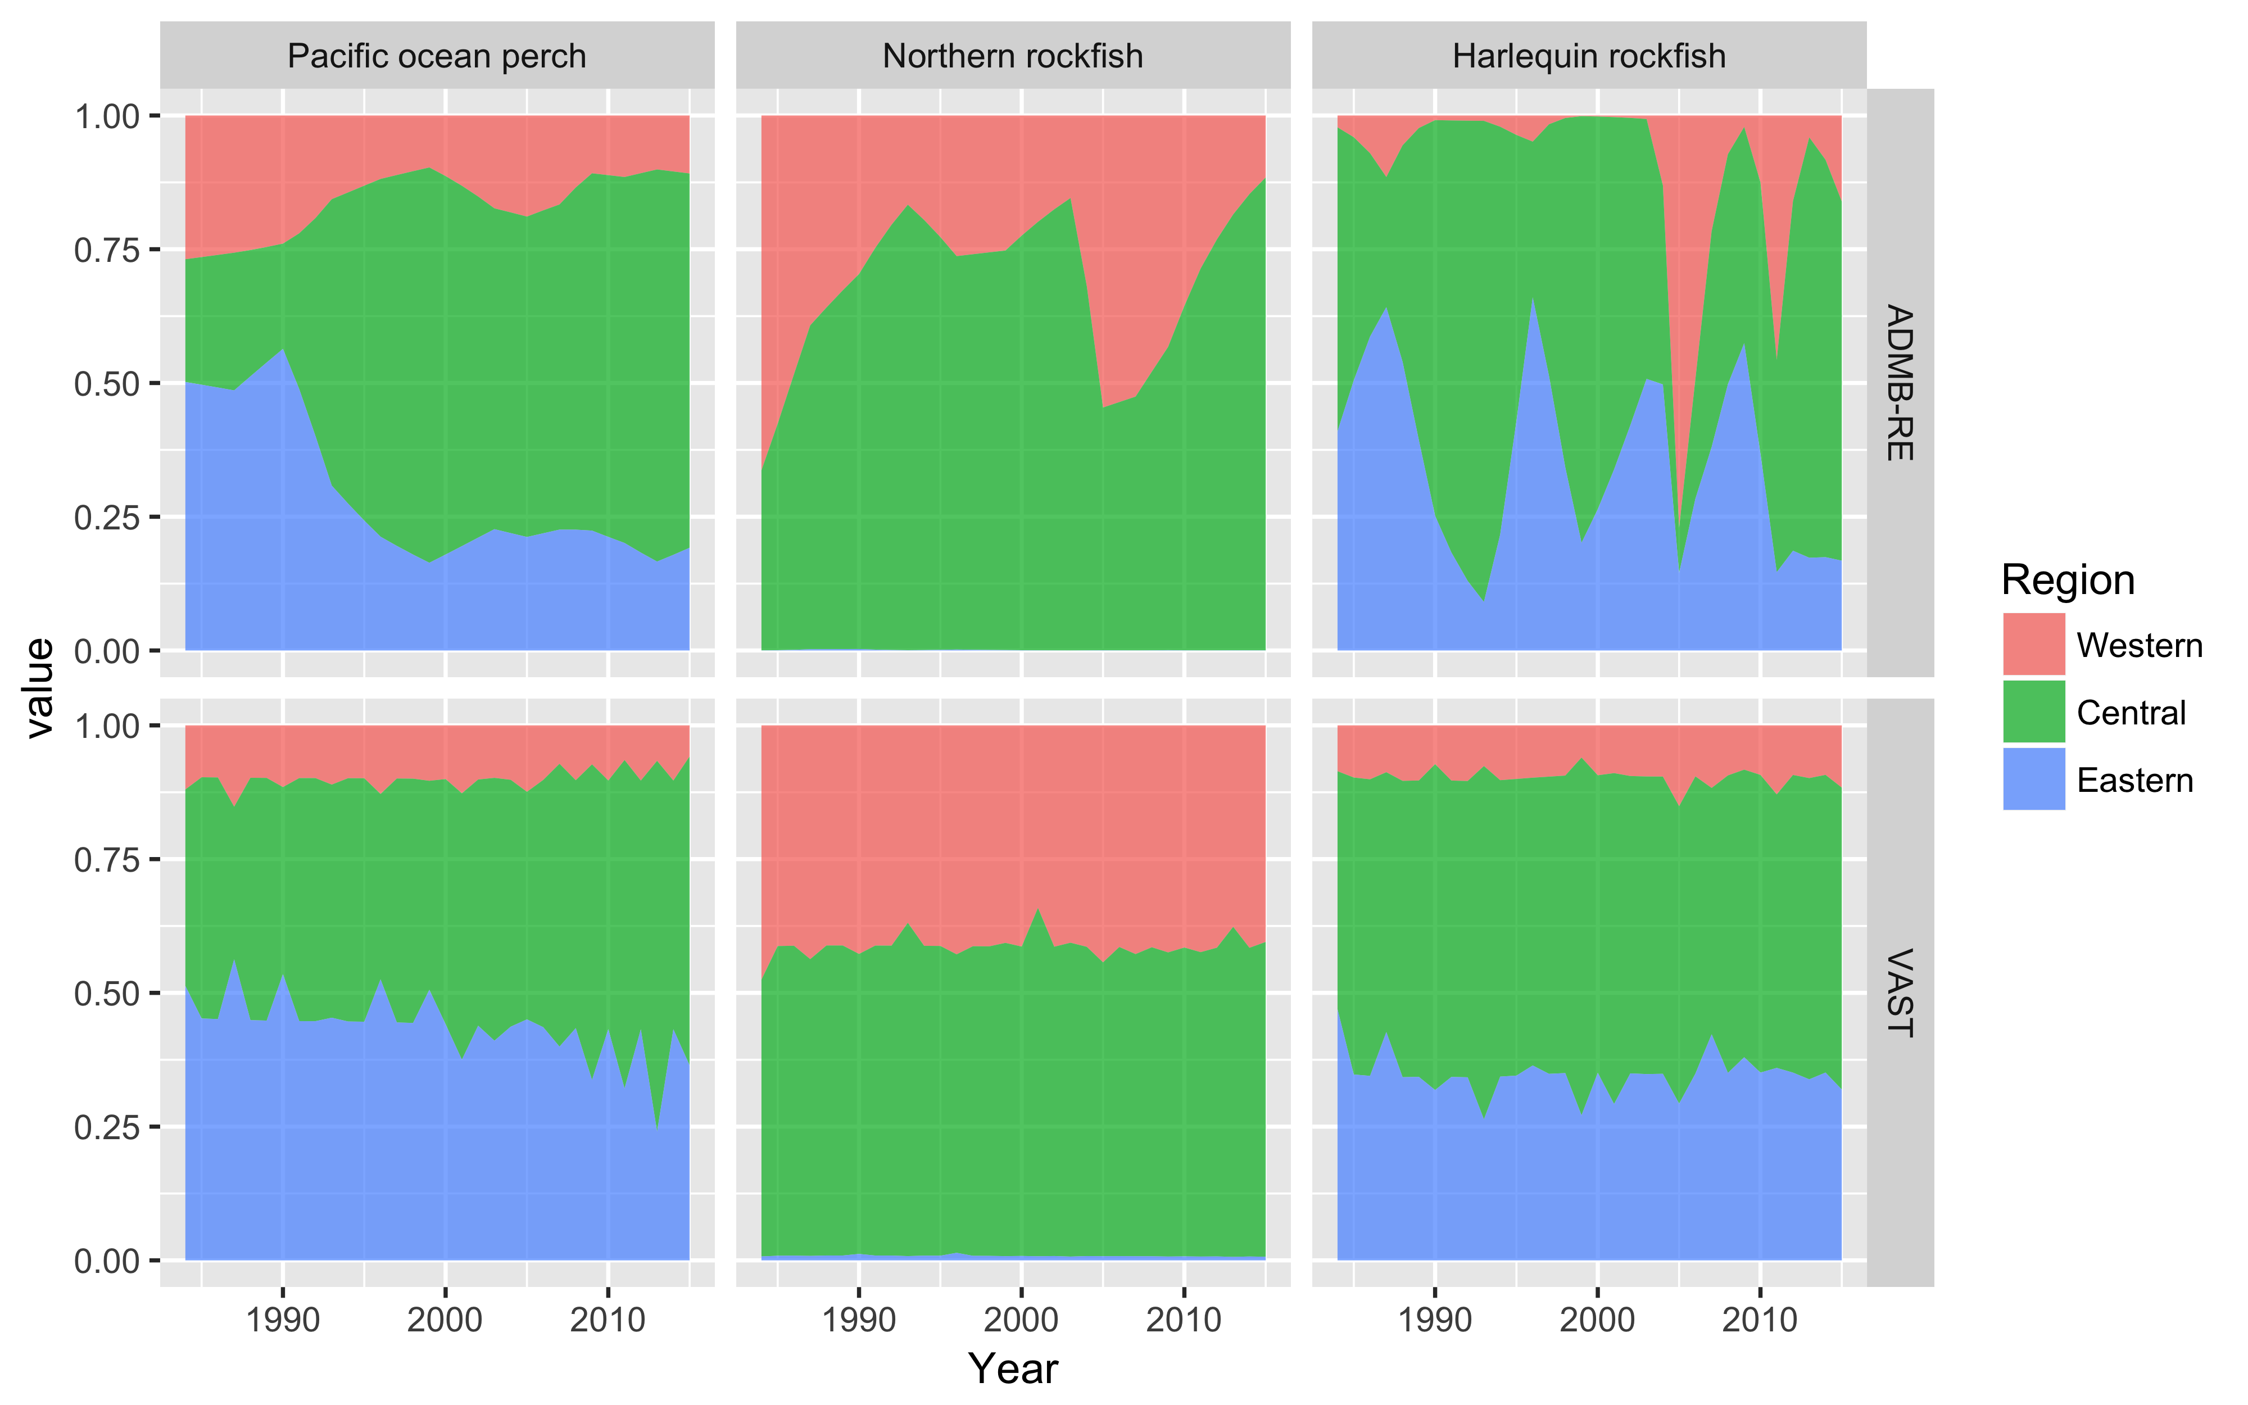

Figure 6 Comparison of apportionment predictions from the ADMB-RE and stratified VAST models, across three rockfish species in the Gulf of Alaska. *Note: Data from 2001 were excluded from the ADMB-RE model, because of zero sampling effort in the Eastern GOA.